Project Design Phase-II
Data Flow Diagram & User Stories

Date | 18th June 2026
Project Name | ShopEZ
Student Name | Akshara Cheedalla

Data Flow Diagrams:

The Flow Diagram illustrates the overall workflow of the ShopEZ online shopping platform by showing how users interact with the system from registration to order completion. It represents the sequence of operations between the customer, application, and database, ensuring smooth data flow throughout the shopping process. The diagram helps visualize how information is processed, stored, and transferred between different modules such as user authentication, product management, cart management, checkout, payment processing, and order tracking. This provides a clear understanding of the system's functionality and supports efficient system design and implementation.
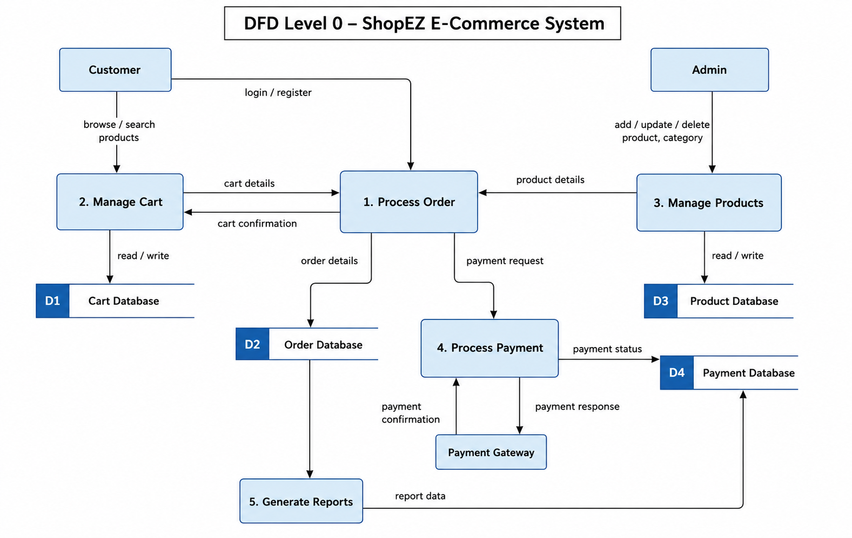
User Stories

User Type | Functional Requirement (Epic) | User Story Number | User Story / Task | Acceptance Criteria | Priority | Release
Customer | Registration | USN-1 | As a customer, I can register using my name, email, and password. | User account is created successfully. | High | Sprint-1
Customer | Login | USN-2 | As a customer, I can log in using valid credentials. | User is redirected to the dashboard. | High | Sprint-1
Customer | Browse Products | USN-3 | As a customer, I can browse available products. | Product list is displayed. | High | Sprint-1
Customer | Search Products | USN-4 | As a customer, I can search products by name or category. | Matching products are displayed. | High | Sprint-2
Customer | Product Details | USN-5 | As a customer, I can view complete product details. | Product information is displayed correctly. | Medium | Sprint-2
Customer | Cart Management | USN-6 | As a customer, I can add products to my cart. | Selected product appears in the cart. | High | Sprint-2
Customer | Cart Management | USN-7 | As a customer, I can update or remove products from the cart. | Cart is updated successfully. | High | Sprint-3
Customer | Checkout | USN-8 | As a customer, I can enter my address and payment details. | Checkout information is saved. | High | Sprint-3
Customer | Place Order | USN-9 | As a customer, I can place an order. | Order confirmation is displayed. | High | Sprint-3
Customer | Order Tracking | USN-10 | As a customer, I can view my order history and order status. | Orders are displayed correctly. | High | Sprint-4
Customer | Profile | USN-11 | As a customer, I can update my profile details. | Profile information is updated successfully. | Medium | Sprint-4
Administrator | Product Management | USN-12 | As an administrator, I can add, edit, and delete products. | Product catalog is updated successfully. | High | Sprint-4
Administrator | Category Management | USN-13 | As an administrator, I can manage product categories. | Categories are created and updated successfully. | Medium | Sprint-4
Administrator | Order Management | USN-14 | As an administrator, I can view and update customer orders. | Order status is updated successfully. | High | Sprint-4
Administrator | User Management | USN-15 | As an administrator, I can manage registered users. | User details are updated successfully. | Medium | Sprint-4
Administrator | Dashboard | USN-16 | As an administrator, I can view sales analytics and reports. | Dashboard displays accurate analytics. | Medium | Sprint-4

